**LAB 4**

**OBJECTIVE**

To implement bit plane slicing and fourier transformation.

**THEORY**

Bit plane slicing is a well known technique used in image processing. In image compression bit plane slicing is used. Bit plane slicing is the conversion of image into multilevel binary image. It is used to convert a gray level image to a binary image, to represent an image with fewer bits and corresponding the image to a smaller size and enhance the image by focusing.

The Fourier Transform is an important image processing tool which is used to decompose an image into its sine and cosine components. The output of the transformation represents the image in the Fourier or frequency domain, while the input image is the spatial domain equivalent. In the Fourier domain image, each point represents a particular frequency contained in the spatial domain image.

The Fourier Transform is used in a wide range of applications, such as image analysis, image filtering, image reconstruction and image compression.

**CODE**

% Program 1 : Bit Plane Slicing

a=imread('image.jpg');

im=rgb2gray(a);

img=double(im);

bp0=mod(img,2);

bp1=mod(floor(img/2),2);

bp2=mod(floor(img/4),2);

bp3=mod(floor(img/8),2);

bp4=mod(floor(img/16),2);

bp5=mod(floor(img/32),2);

bp6=mod(floor(img/64),2);

bp7=mod(floor(img/128),2);

% Merging all bit planes

bp_all=2*(2*(2*(2*(2*(2*(2*bp7+bp6)+bp5)+bp4)+bp3)+bp2)+bp1)+bp0;

subplot(241);imshow(bp0);title('Bit-Plane 0 : LSB');

subplot(242);imshow(bp1);title('Bit-Plane 1');

subplot(243);imshow(bp2);title('Bit-Plane 2');

subplot(244);imshow(bp3);title('Bit-Plane 3');

subplot(245);imshow(bp4);title('Bit-Plane 4');

subplot(246);imshow(bp5);title('Bit-Plane 5');

subplot(247);imshow(bp6);title('Bit-Plane 6');

subplot(248);imshow(bp7);title('Bit-Plane 7 : MSB');

figure

subplot(121),imshow(uint8(bp_all)),title('Processed');

subplot(122),imshow(im),title('Original')

**OUTPUT**

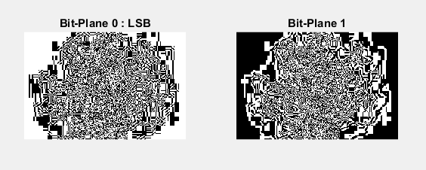

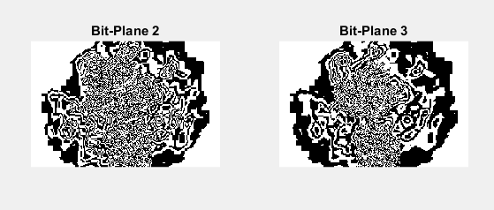

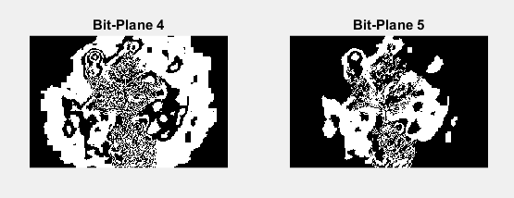

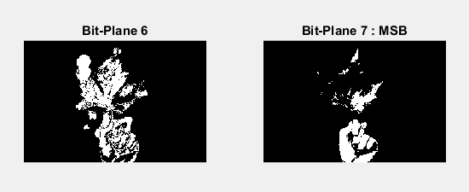

**CODE**

% Program 2 : Fourier Transformation

I=imread('image.jpg');

I=im2double(I);

%(DFT) get the frequency for the image

FI=fft2(I);

%Shift zero-frequency component to center of img_spectrum

FI_S=abs(fftshift(FI));

I1=ifft2(FI);

I2=real(I1);

subplot(131),imshow(I),title('Original');

subplot(132),imagesc(0.5*log(1+FI_S)),title('Fourier Spectrum')

,axis off

subplot(133),imshow(I2),title('Reconstructed')

**OUTPUT**

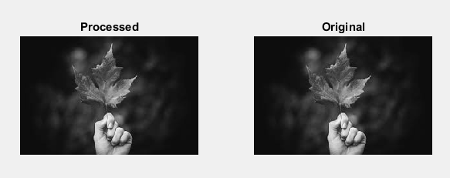

**CONCLUSION**

In this lab, I got familiar with bit plane slicing and fourier transformation.